Tax Invoice as per GST

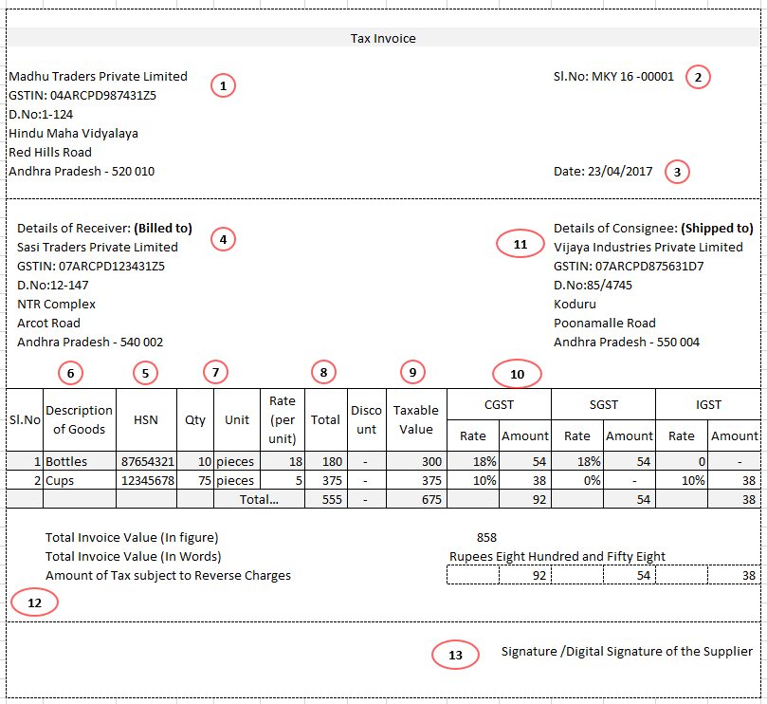

- Name, address and GSTIN of the supplier;
- consecutive serial number, in one or multiple series, containing alphabets or numerals or special characters hyphen or dash and slash or any combination thereof, unique for a financial year
- date of its issue

- • If registered: Name, address and GSTIN or UIN of the recipient;
• If unregistered: Name and address of the recipient and the address of delivery, along with
the name of State and its code and where the value of taxable supply is fifty thousand
rupees or more
- HSN code of goods or Accounting Code of services
- Description of goods or services
- Quantity in case of goods and unit or Unique Quantity Code thereof
- Total value of supply of goods or services or both
- Taxable value of supply of goods or services or both taking into account discount or abatement, if any
- Rate of tax and Amount of tax (central tax, State tax, integrated tax, Union territory tax or cess
- Place of supply along with the name of State, in case of a supply in the course of inter-State trade or commerce and address of delivery where the same is different from the place of supply
- Whether the tax is payable on reverse charge basis and
- Signature or digital signature of the supplier or his authorized representative

